HARDWARE DOCUMENT

Project: ECSE 211 Search & Retrieval Robot
Task: Overall hardware and structural design

Document Version Number: 1.2.1
Date: February 25, 2020
Author: Yazdan Zinati
Edit History:
Date | Version | Author(s) | Changes
Feb 25 | 1.0 | Yazdan Zinati | First draft
Feb 25 | 1.1 | Yazdan Zinati | Elaborated sections 1.0 - 8.0
Feb 25 | 1.2 | Yazdan Zinati | Elaborated section 9.0
Feb 25 | 1.2.1 | Andy Li  William Bouchard | Improved formatting and table of contents

1 – TABLE OF CONTENTS
2.0 – HARDWARE DESIGN PROCESS 3
3.0 – PURPOSE 3
4.0 – RESOURCES 3
5.0 – DESIGN CONSTRAINTS 3
6.0 – RESEARCH AND DEVELOPMENT 3
7.0 – DESIRED FEATURES AND REQUIRED COMPONENTS 4
8.0 – PRELIMINARY DESIGN 5
8.1 – COMPONENT COUNT AND PLACEMENT 5
8.2 – PRELIMINARY DESIGNS 6
8.2.1 – PRELIMINARY DESIGN 1 6
8.2.2 – PRELIMINARY DESIGN 2 8
8.2.3 – PRELIMINARY DESIGN 3 10

2.0 – HARDWARE DESIGN PROCESS
We started the design process of the robot based on three important documents: the System Document, which defines the available hardware, its capabilities and limitations, and key features (e.g., reusability and compatibility); the Requirements Document, which defines the purpose, constraints, and desired features of the robot; and the Constraints Document, which shows the limitations we must consider in the hardware design.
We created the preliminary designs based on the design features, taking into account the constraints and limitations we must work with. We then expect to evaluate and compare the relative advantages of each design to narrow down our ideas to the preferred design of the hardware. However, even this preferred design may be later modified to resolve unexpected problems in the future.

3.0 – PURPOSE
For a detailed discussion of the purpose, refer to Section 2.0 of the Requirements Document.

4.0 – RESOURCES
The resources are those found in the three Mindstorms EV3 kits, the contents of which are listed in Section 3.0 of the System Document.

5.0 – DESIGN CONSTRAINTS
The design constraints are listed in the Constraints Document.

6.0 – RESEARCH AND DEVELOPMENT
Since the beginning of this course, we have completed five labs that address different elements of our final design; thus, the hardware design from the previous labs is relevant to our final project. Since the first four labs were completed in smaller labs than Lab 5, we were able to integrate components from each lab in the hardware design for the final lab (Figure 1). We expect to use elements from this hardware design for the project, as we plan to use a similar array of sensors and motors on the final design.
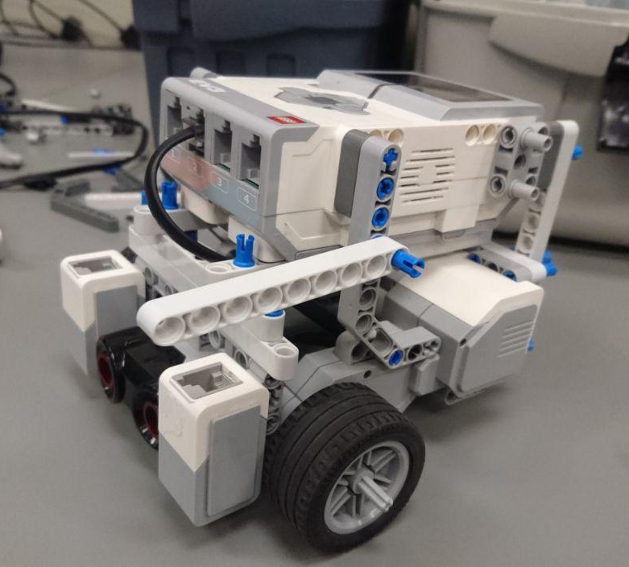
Figure 1: Lab 5 base robot design

7.0 – DESIRED FEATURES AND REQUIRED COMPONENTS
Localization:
- 1 ultrasonic sensor
- 1-2 light sensors (only if light localization is used)

Odometer error correction:
- 2 light sensors

Navigation:
- 2 large motors
- 1 steel ball bearing

Obstacle avoidance:
- 1-2 ultrasonic sensors

Hooking mechanism:
- 1-2 medium motors

8.0 – PRELIMINARY DESIGN

8.1 – COMPONENT COUNT AND PLACEMENT
Ultrasonic sensors
Placement | Advantages | Disadvantages
Bottom, center  (1 sensor) | Detects low obstacles  Localizer code can be reused | Increases width, wheelbase
Top, center  (1 sensor) | Reduces width, wheelbase  Localizer code can be reused | Increases robot height  Only detects tall obstacles  Reduced obstacle detection
Top, forward  (2 sensors) | Reduces width, wheelbase  Improved obstacle detection | Increases robot height  Only detects tall obstacles  Localizer code must be rewritten
Facing outward  (2 sensors) | Improved obstacle detection | Localizer code must be rewritten  Increases robot width

Light sensors
Placement | Advantages | Disadvantages
None | Reduces robot width  No coding necessary | No odometer correction
Back of robot  (1 sensor) | Reduces robot width  Localizer code can be reused | Robot must spin to correct odometer
Sides of robot  (2 sensors) | Quick odometer correction | Increases robot width, power consumption  Localizer code must be rewritten

8.2 – PRELIMINARY DESIGNS

8.2.1 – PRELIMINARY DESIGN 1 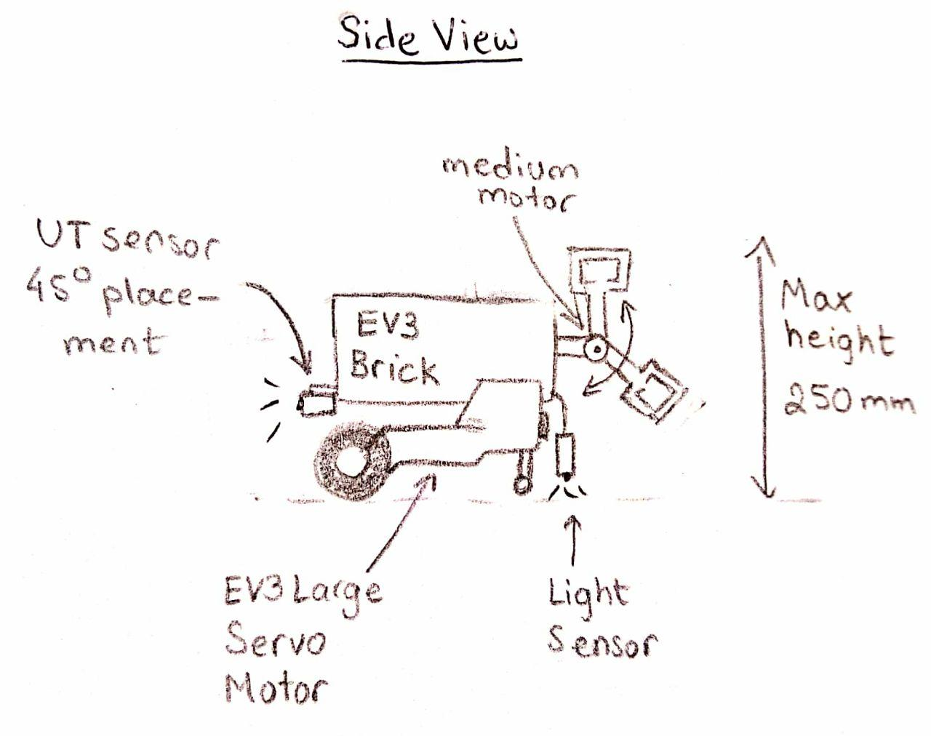
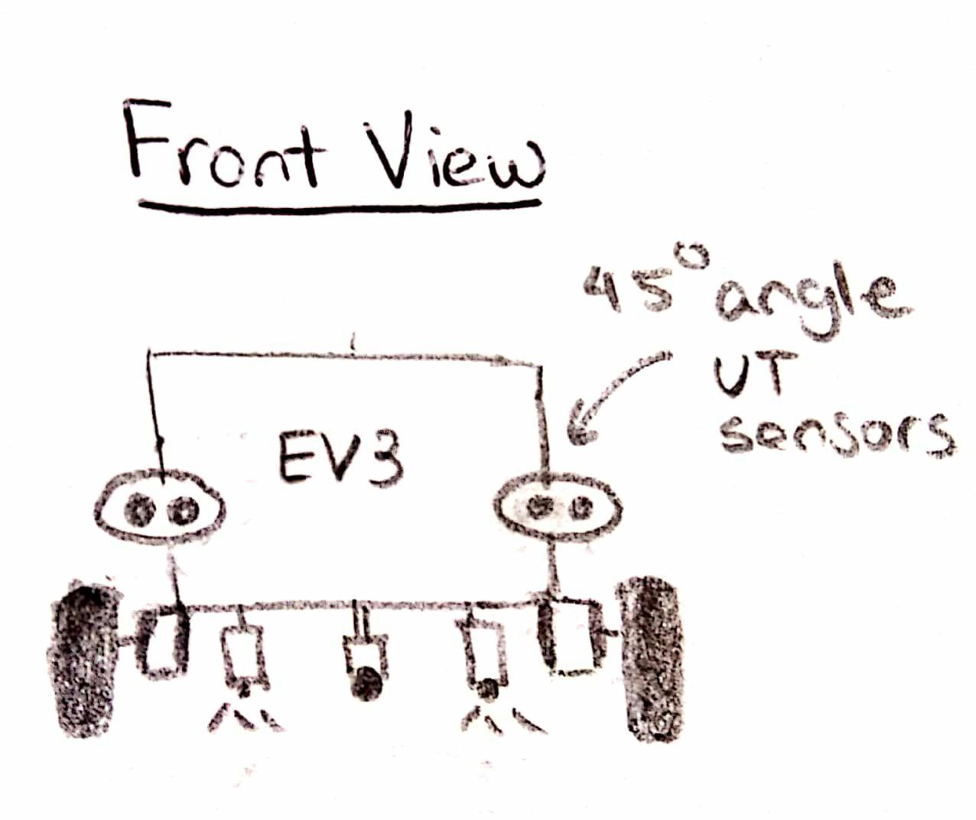

This design consists of two ultrasonic sensors, each placed at a 45 degree angle in the front of the robot, for object detection and ultrasonic localization. Two light sensors, mounted in the back, can be used for odometer correction and light localization. Placing the light sensors in the back reduces the width of the robot. Other variations of this robot could have bottom mounted motors to further reduce the width.
Components:
- 2 wheels
- 2 large EV3 motors
- 1 medium motor
- 2 ultrasonic sensors
- 2 light/colour sensors
Advantages:
- Relative simplicity
- Two light sensors improve odometer correction
- Reduced robot width
Disadvantages:
- Motor at back of robot adds weight
- Ultrasonic localization requires new code
- Small distance between light sensors reduces accuracy

8.2.2 – PRELIMINARY DESIGN 2

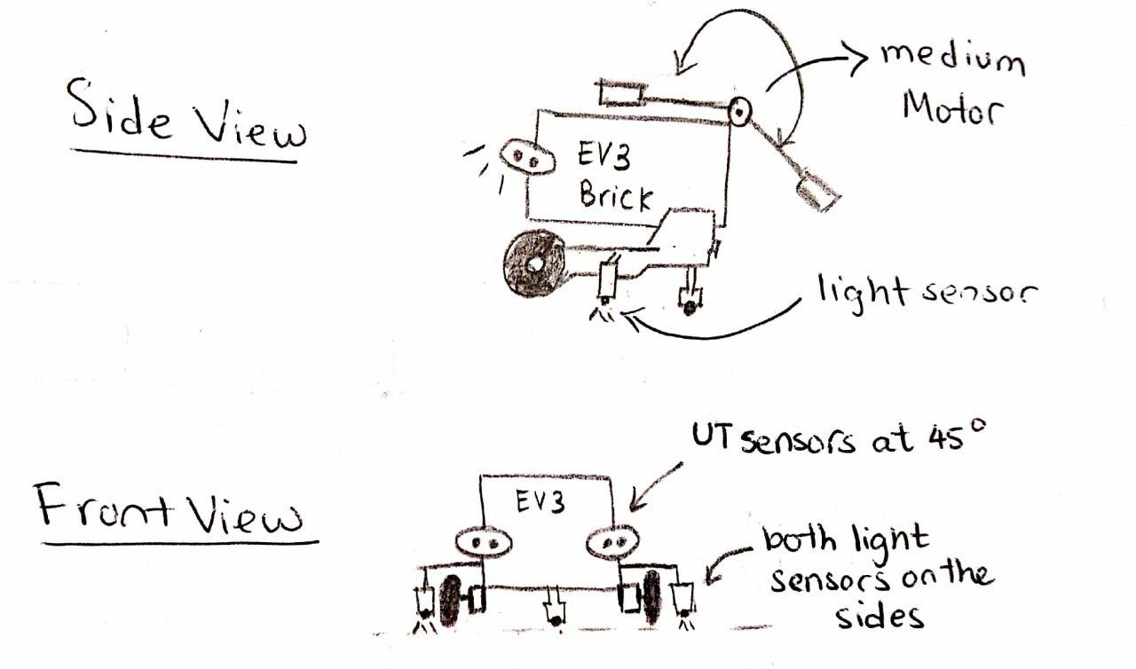
This design contains two ultrasonic sensors, each placed at a 45 degree angle in the front of the robot; the two sensors are used for both object detection and ultrasonic localization. Two light sensors, which can be used for odometer correction and light localization, are also mounted on the sides. The large distance between the side mounting light sensors makes detecting the odometer error easier. However, the robot is also wider, which could cause issues in the tunnel or when turning.
Components
- 2 wheels
- 2 large EV3 motors
- 1 medium motor
- 2 ultrasonic sensors
- 2 light/colour sensors
Advantages:
- Two light sensors improve odometer correction, reduce drift
- Distance between sensors increases sensor accuracy
- Improved front-back weight balance
Disadvantages:
- Width of robot reduces maneuverability
- Ultrasonic localization requires new code

8.2.3 – PRELIMINARY DESIGN 3

n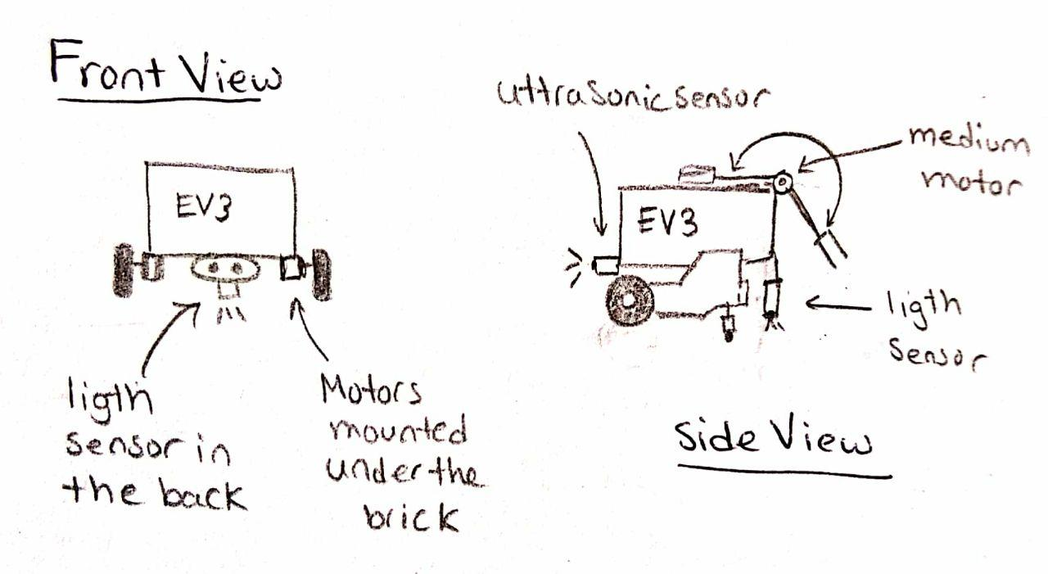

This design resembles the robot we used in Lab 5. It only has one (front-mounted) ultrasonic sensor and one (rear-mounted) light sensor. The motors and ultrasonic sensor are mounted on the bottom of the brick . This allows the robot to be only slightly wider than the EV3 brick itself.
Components:
- 2 wheels
- 2 large EV3 motors
- 1 medium motor
- 1 ultrasonic sensor
- 1 light/color sensor
Advantages:
- Relative simplicity
- Reduced robt width
- Localization code can be reused
- Improved front-back weight balance
Disadvantages:
- Ultrasonic sensor has reduced field of view
- Light localization requires robot to spin

